1.

#include <stdio.h>

int main() {

int arr[100];

int size, i;

printf("Enter the size of the array: ");

scanf("%d", &size);

printf("Enter elements of the array:\n");

for (i = 0; i < size; i++) {

printf("Enter element %d: ", i + 1);

scanf("%d", &arr[i]);

}

printf("Elements of the array are: ");

for (i = 0; i < size; i++) {

printf("%d ", arr[i]);

}

printf("\n");

return 0;

}

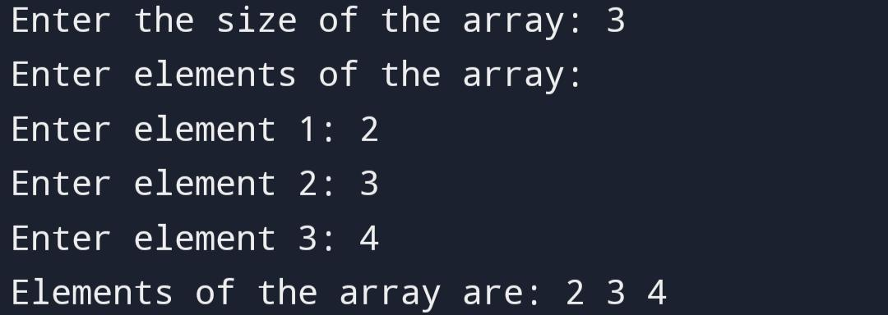

2.

#include <stdio.h>

int main() {

int n, i;

printf("Enter the number of elements: ");

scanf("%d", &n);

int arr[n];

printf("Enter %d elements:\n", n);

for (i = 0; i < n; i++) {

scanf("%d", &arr[i]);

}

printf("Elements in reverse order:\n");

for (i = n - 1; i >= 0; i--) {

printf("%d ", arr[i]);

}

return 0;

}

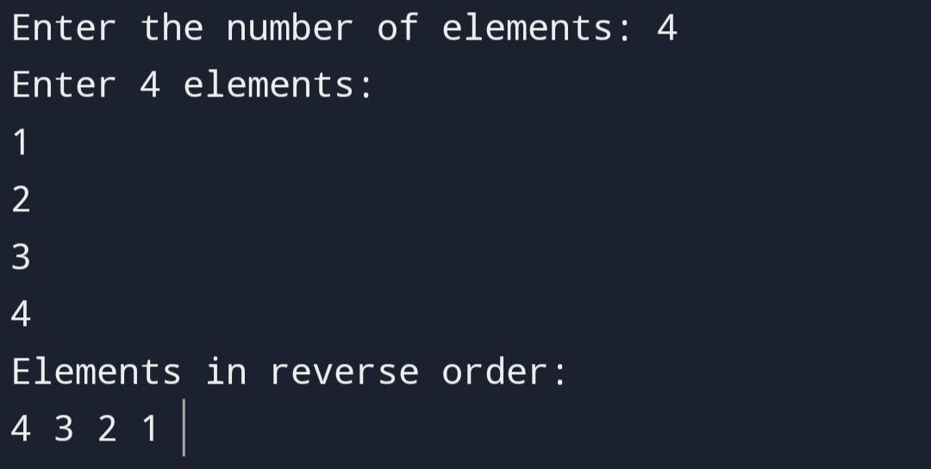

3.

#include <stdio.h>

int main() {

int i,n,sum=0;

printf("enter the number of elements\n");

scanf("%d",&n);

int arr[n];

for(i=0;i<n;i++){

printf("enter the element\n");

scanf("%d",&arr[n]);

}

for(i=0;i<n;i++){

sum=sum+arr[n];

}

printf("sum of all elements of array=%d",sum);

return 0;

}

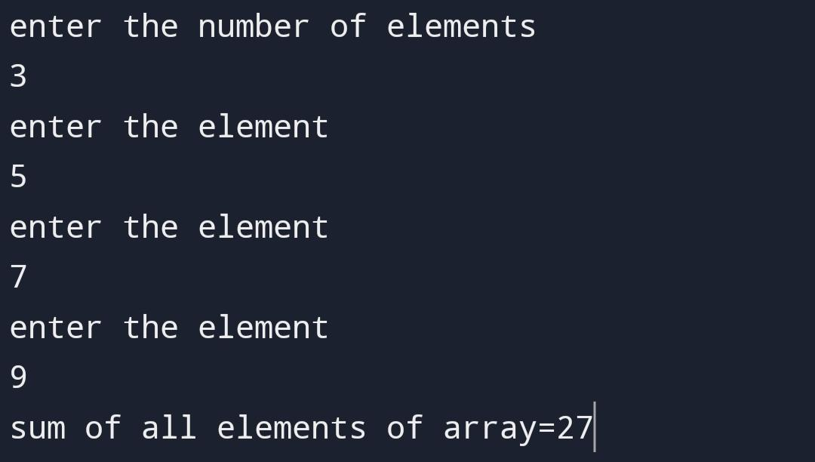

4.

#include <stdio.h>

int main()

{

int arr[100];

int i, j, n , count = 0;

printf("Enter size of the array : ");

scanf("%d", &n);

for(i=0; i<n; i++)

{

printf("Enter element in array "%d": ",i+1);

scanf("%d", &arr[i]);

}

for(i=0; i<n; i++)

{

for(j=i+1; j<n; j++)

{

if(arr[i] == arr[j])

{

count++;

break;

}

}

}

printf("\nTotal number of duplicate elements found in array = %d", count);

return 0;

}

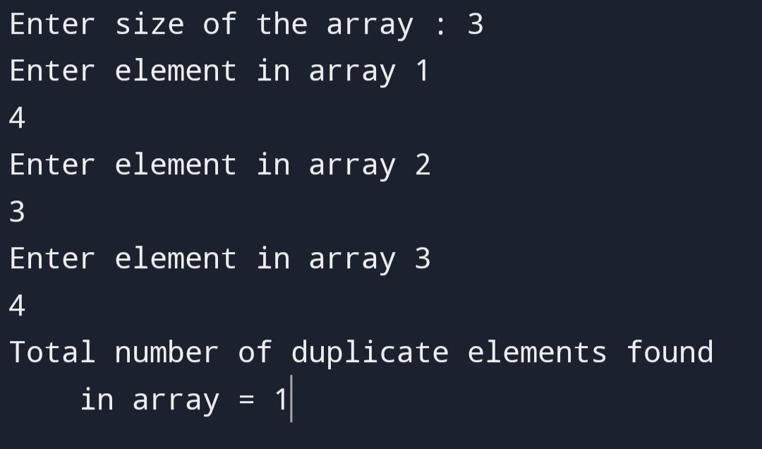

5.

#include <stdio.h>

int main()

{

int arr[100];

int i, j, n ;

printf("Enter size of the array : ");

scanf("%d", &n);

for(i=0; i<n; i++)

{

printf("Enter element in array"%d\n",i+1);

scanf("%d", &arr[i]);

}

printf("unique elements in array\n");

for(i=0; i<n; i++)

{

for(j=i+1; j<n; j++)

{

if(arr[i] != arr[j])

{

printf("%d\n",arr[i]);

}

}

}

return 0;

}

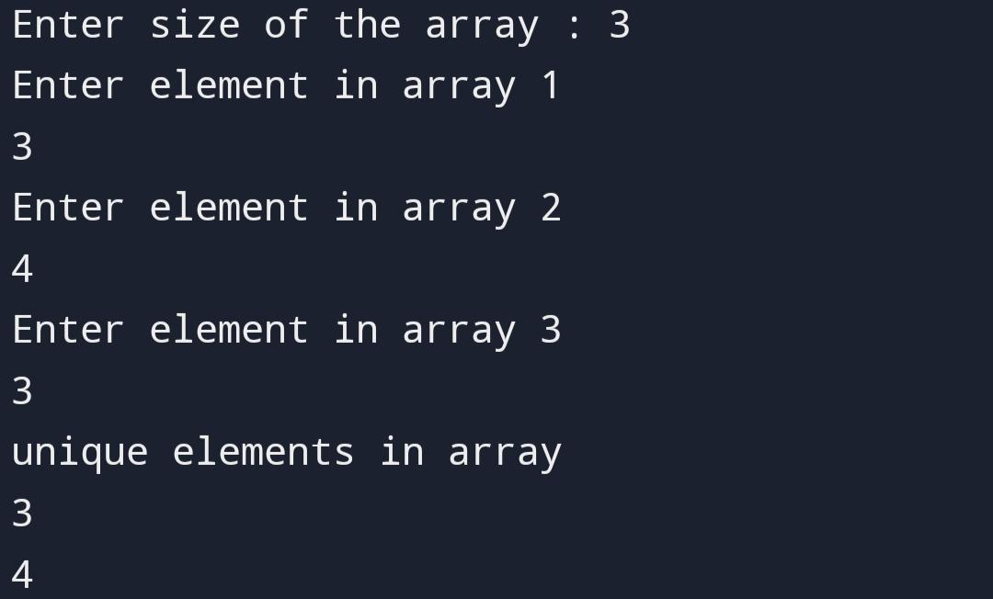

6.

#include <stdio.h>

int main() {

int a[8];

int i;

printf("Enter 7 integers: ");

for (i = 0; i < 7; i++) {

scanf("%d", &a[i]);

}

printf("Array elements before modification: ");

for (i = 0; i < 7; i++) {

printf("%d\n", a[i]);

}

printf("\n");

int temp = 9;

for (i = 7; i > 4; i--) {

a[i] = a[i - 1];

}

a[4] = temp;

printf("After insertion: ");

for (i = 0; i < 8; i++) {

printf("%d\n", a[i]);

}

printf("\n");

return 0;

}

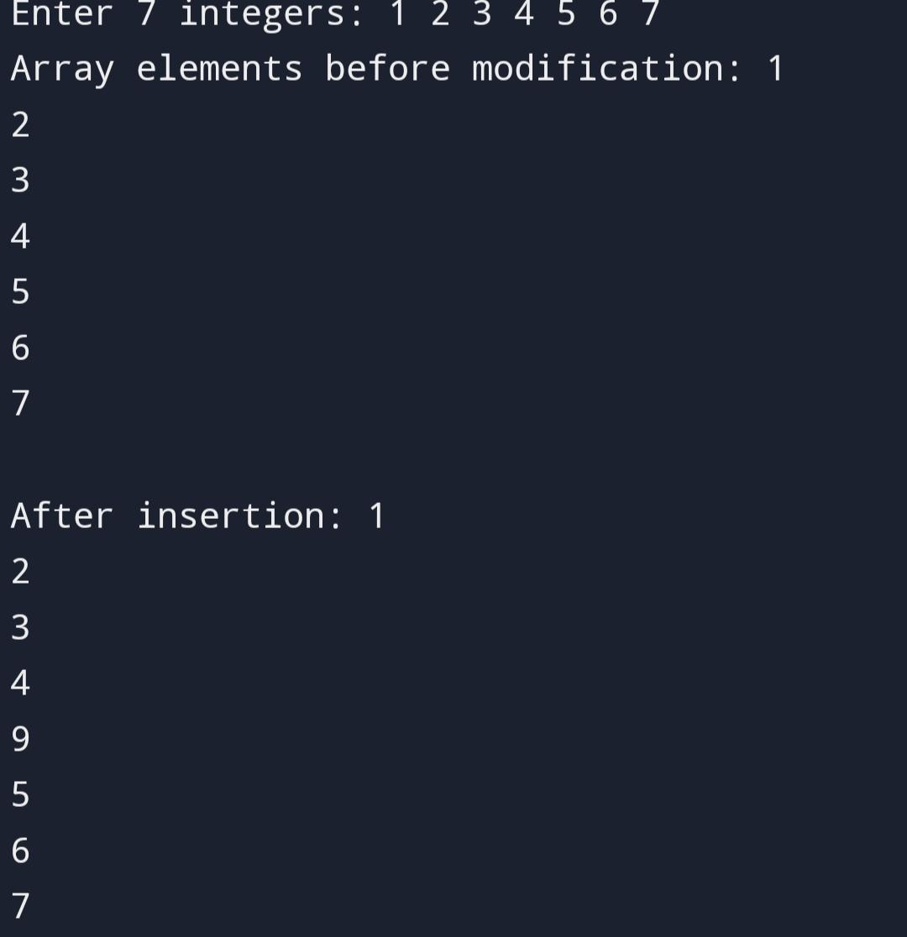

7.

#include<stdio.h>

int main() {

int a[100];

int i, n;

printf("Enter the value of n: ");

scanf("%d", &n);

printf("Enter the array elements: ");

for (i = 0; i < n; i++) {

scanf("%d", &a[i]);

}

printf("Array elements: ");

for (i = 0; i < n; i++) {

printf("%d ", a[i]);

}

printf("\n after %d is deleted then:" , n);

for (i = 0; i < n; i++) {

if (a[i] != n) {

printf("%d ", a[i]);

}

}

return 0;

}

